**Exploration and Visualisation of Dataset**

**M.SURYA**

**310619104317**

**Team ID PNT2022TMID09237**

**State by Marketing Spend**

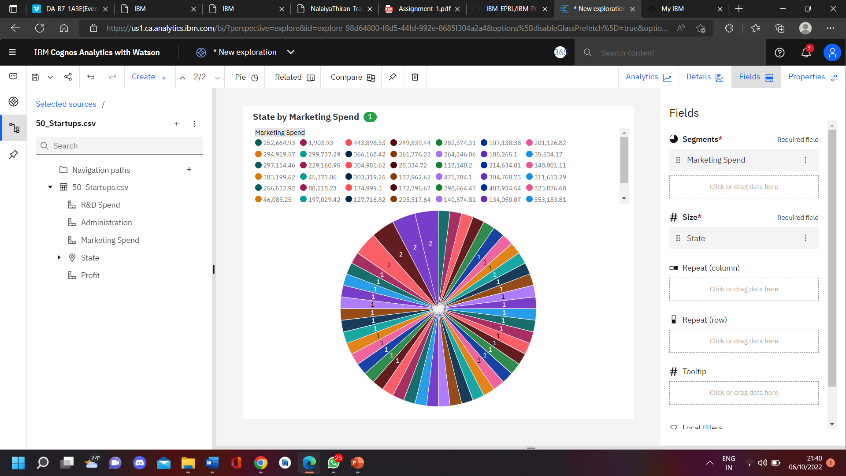

**Profit and State by Marketing Spend and Administration**

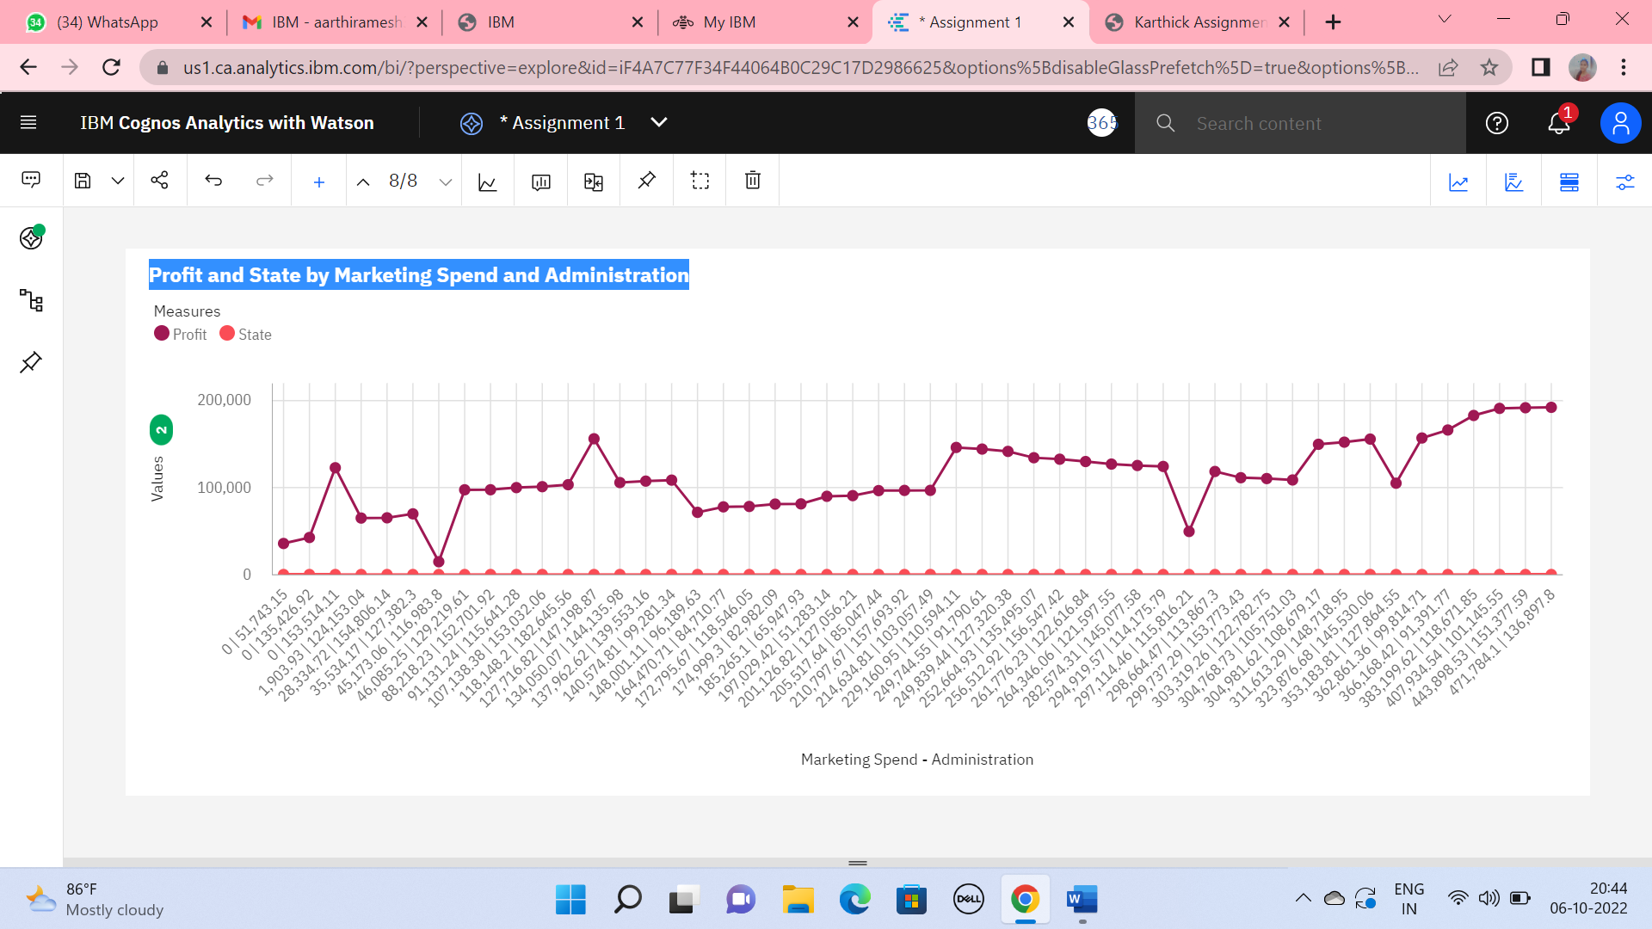

**R&D Spend by Marketing Spend**

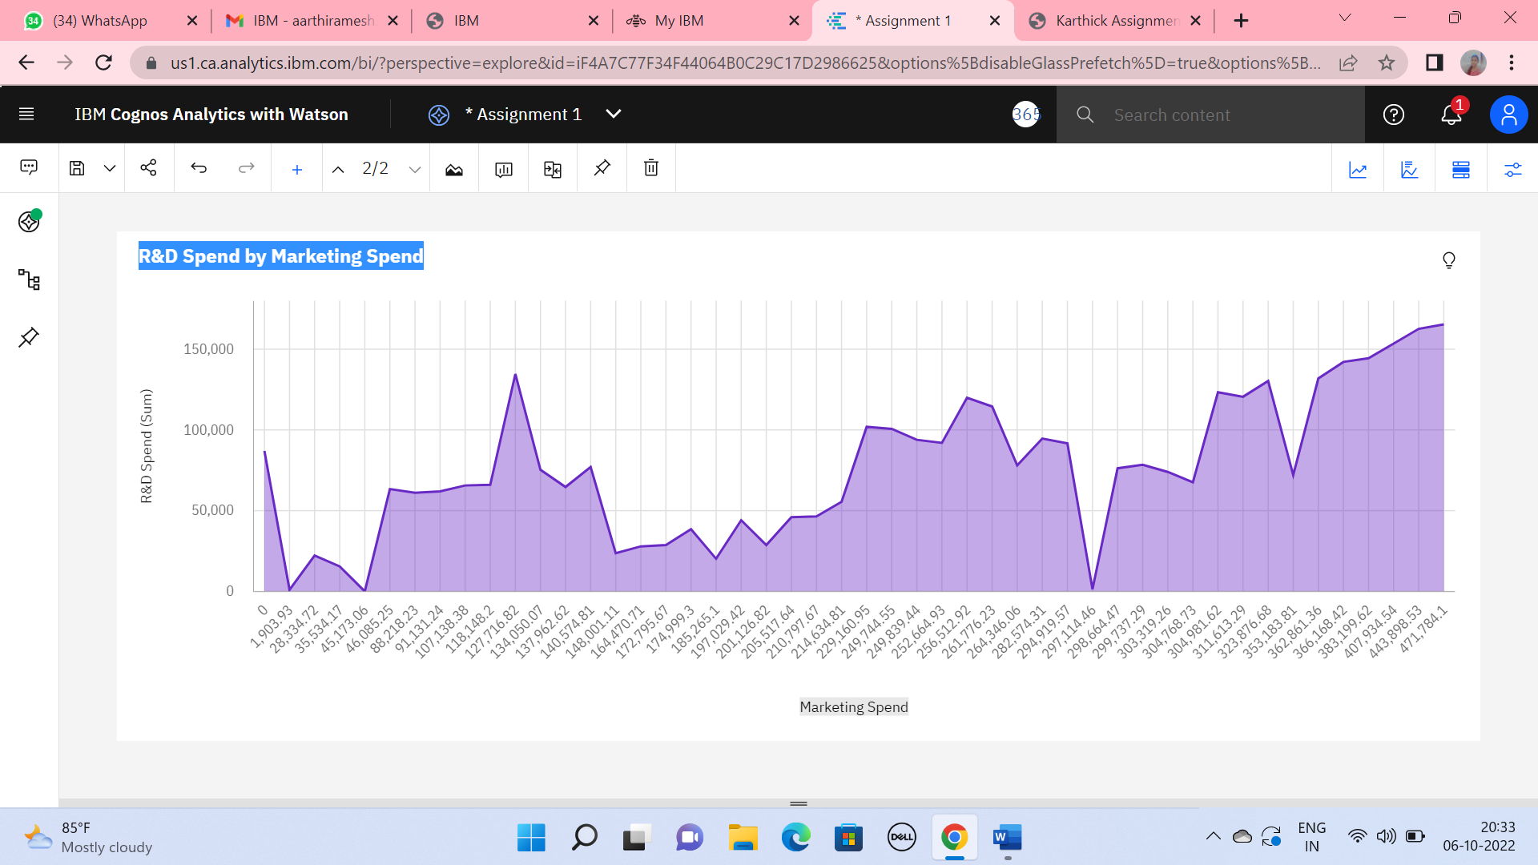

**Profit and R&D Spend for R&D Spend Marketing Spend Administration**

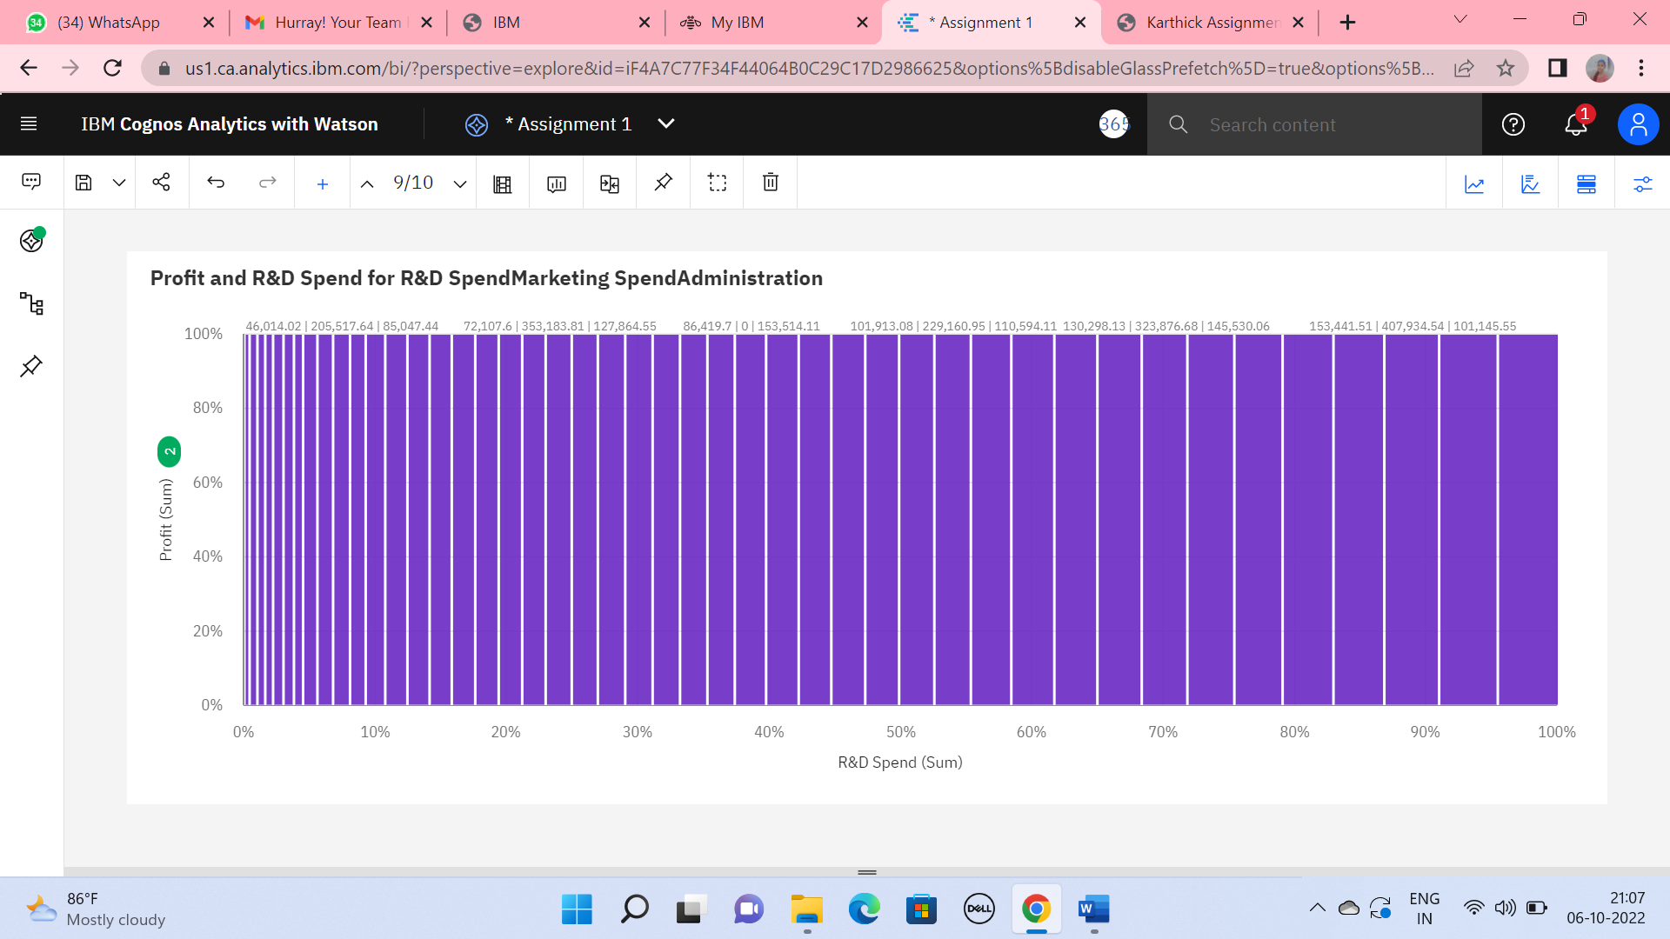

**Administration by R&D Spend**

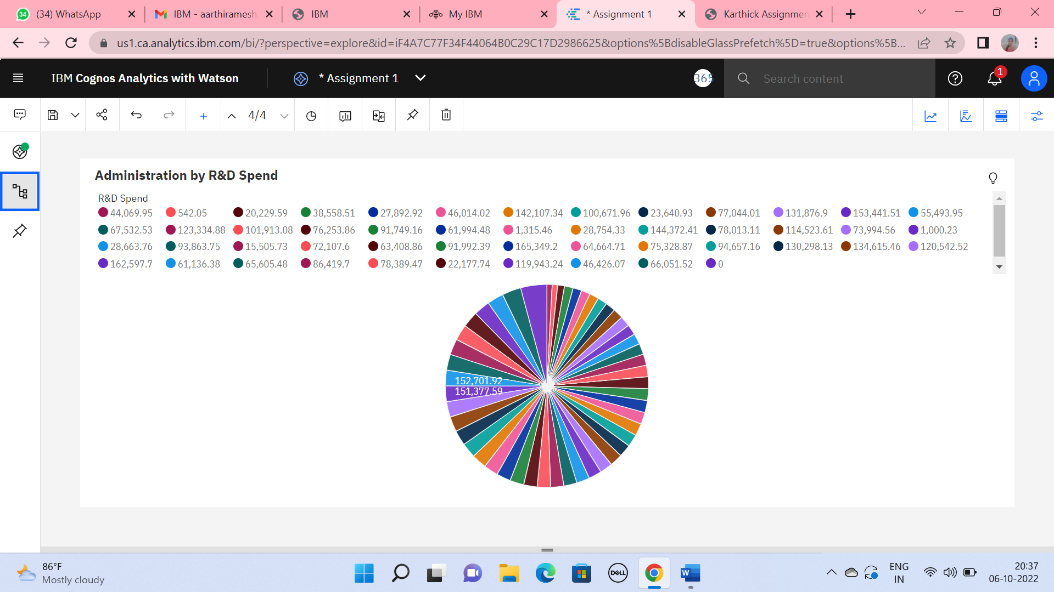

**Administration by Profit and State**

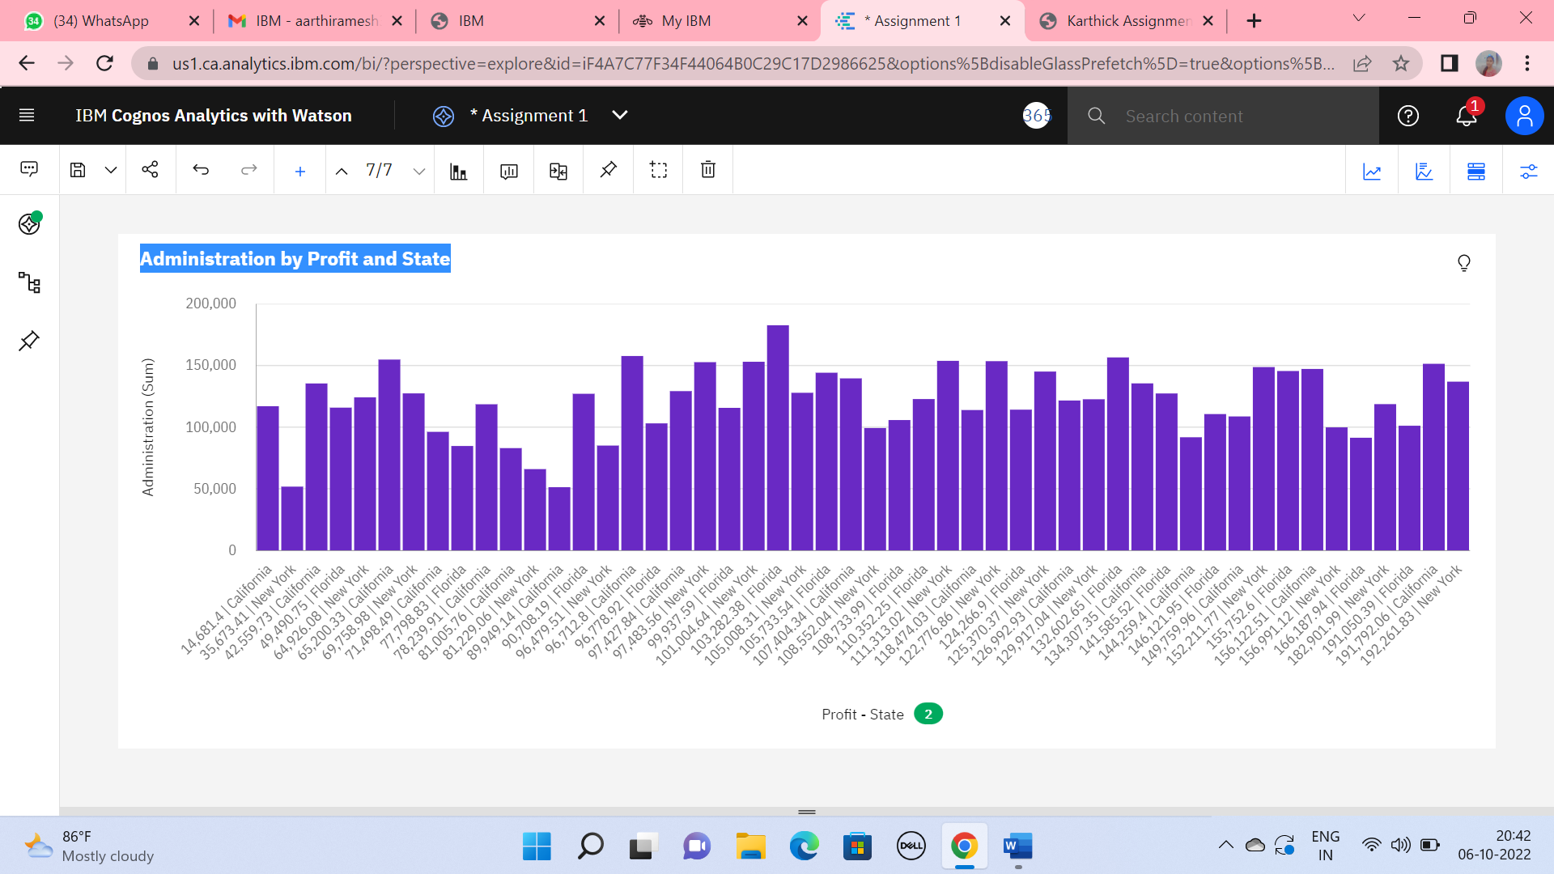

**Profit by R&D Spend**

